Pre-test/Post-test : Telephone calls.

Instruction
- There are 10 questions in this paper. Task includes 4-option multiple choice.
- Answer all questions.
- Mark your answer on the separate answer sheet.
- Time 10 minutes.
- Each question in this paper carries one mark.

Choose the best option to complete each dialogue about telephone calls.
Mark the correct letter [A,B,C,D] on your answer sheet.

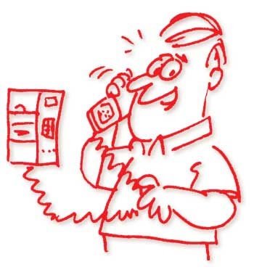
1. A : ……………………………..
B : I’m afraid she’s not in just now.
a. Hi , Tom. How’s she?
b. Hello , may I’ve a word with Betty , please?
c. She’s inside , isn’t she?
d. What’s the matter?
------------------------------------------------------------------------------------------------------------
2. Situation : You call your friend , who isn’t at home. Ask her sister to take a message.
a. Could you take my note?
b. Could I give you a note?
c. Could I leave her a message?
d. Could I take a message?
------------------------------------------------------------------------------------------------------------
3. A : Can I talk to Penny , please?
B : There’s nobody that name here. I’m afraid you’ve got the wrong number.
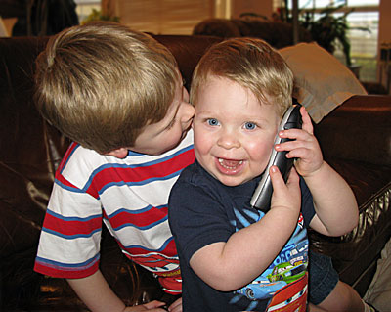
A : …………………………
a. Thank you for telling me that. Good bye.
b. I’m sorry. Good bye.
c. Thank you. I won’t call you again.
d. I’m sorry. I won’t call you again
------------------------------------------------------------------------------------------------------------

On the phone
Operator : Information. May I help you?
Pim : Would you please give me the telephone number of Mr. Jim Thompson?
4
Operator : …………………….. The number is 044-233-4221
5
Pim : 044-233-4221 ………………………………..
Operator : Good morning. Mr. Thompson’s office.
Pim : I’d like to speak with Mr. Thompson , please.
6
Decretary : ……………………..
Pim : This is Pim Pakid speaking. Will Mr.Thompson be back soon?
7
Secretary : ……………………..
Pim : Well , could you tell him that I called , please?
Decretaryr : One moment , please . I think he’s coming in now
Pim : All right. Thank you.
4. a. Yes , I will.
b. Excuse me , please.
c. We’ve at your service.
d. Just a moment , please.

----------------------------------------------
5. a. That’s all
b. Well , yes.
c. Thank you.
d. All right.
----------------------------------------------
6. a. Hold on please I’ll see if he’s in. Who should I say is calling?
b. I’m sorry. He’s not in right now , Who’s calling , please?
c. All right. Let me check his diary. May I have your name?
d. Let me check whether he’s back yet , Could you leave your name and number ,
please.
------------------------------------------------------------------------------------------------------------
7. a. I expect him in about an hour. Why do you want to talk to him?
b. Probably about five o’clock. Do you want to leave a message?
c. At five. Do you want any information from him?
d. I think he’ll be back in thirty minutes. When would you like to see him?
------------------------------------------------------------------------------------------------------------
8. A : Hello , is Bonnie there?

B : ……………………….
C : Bonnie speaking.
D : Hello , Bonnie , This is Sue.
a. Can I take a message?
b. Hang up , please.
c. Hold on.
d. She’s out.
------------------------------------------------------------------------------------------------------------
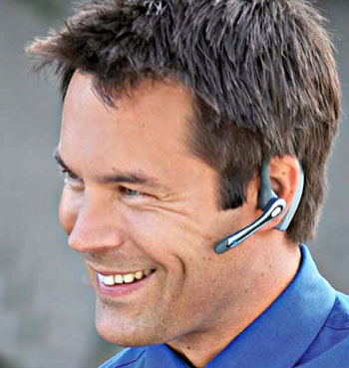
9. A : Hello. Is this Alex?
B : …………………………..
a. Yes it is.
b. No , I’m not.
c. Yes , he is.
d. No , this is not me.
------------------------------------------------------------------------------------------------------------
10 A : Hello. Is Kay there?
B : …………………………
A : Oh? I don’t recognize your voice. Would you like to go to the movies tonight?

a. This is I.
b. This is she speaking.
c. Kay is my name.
d. Yes , I’m here.

------------------------------------------------------------------------------------------------------------

Name…………………………Class…………No……….
Title……………………………Date……………………..
_____________________________________________________________
Instruction
Mark the correct letter [A,B,C,D] on your answer sheet.
A
B
C
D
1.
A
B
C
D
2.
A
B
C
D
3.
A
B
C
D
4.
A
B
C
D
5.
A
B
C
D
6.
A
B
C
D
7.
A
B
C
D
8.
A
B
C
D
9.
A
B
C
D
10.

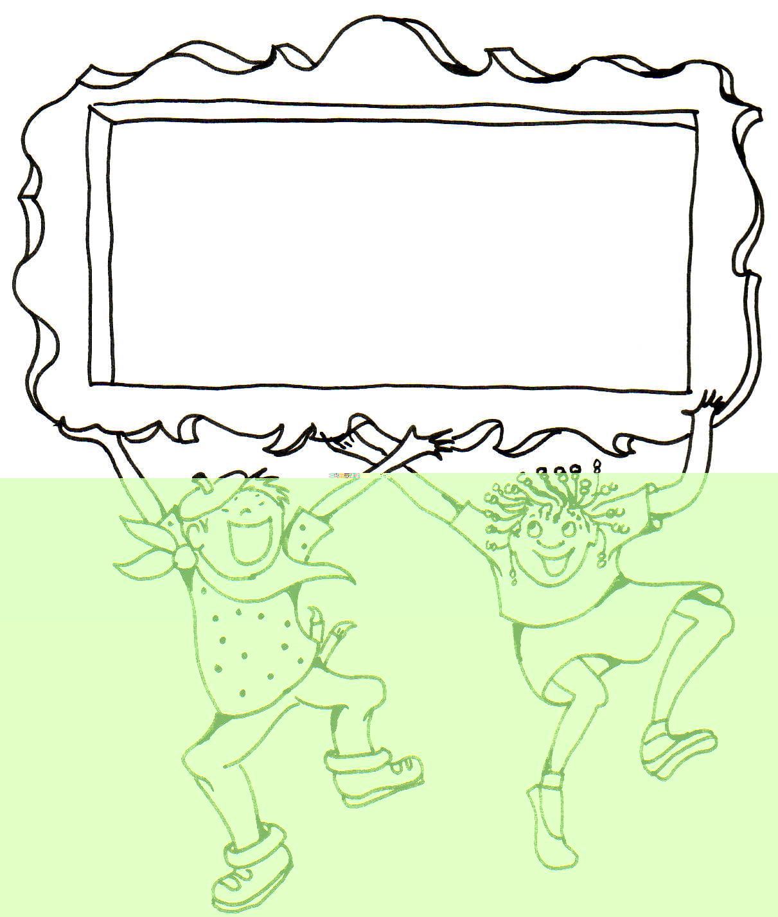

Answer key
for pre-test/ post-test

1. b. 2. c. 3. b. 4. d. 5. c.
6. b. 7. b. 8. c. 9. c. 10. b.



A lot of people find it difficult to make phone calls in a foreign language and that’s understandable. You can’t see the person you are talking to, their voice might be unclear, and you might find it difficult to find the right words.
There are a number of phrases and idioms that are used when telephoning. Let’s first take a look at the chart below for useful phrases and example dialogues.



Language in use
Language for telephone calls

1. Introducing yourself.

Dang here.

Hello , This is Jim.

Yupin speaking.

Speaking.

This is she (he).

This is she (he) speaking.





2. Asking who is on the telephone
Excuse me, who is this?
Can I ask who is calling, please?
Who am I speaking to, please?
Whom do you want to speak to?
Whom shall I say is calling?
Who’s this speaking, please.

Who’s that?

Is that Mr.Winai?
Is that 044471105?
Who would you like to speak to?

3. Asking for someone
May I have a word with Miss Tussanee , please
May I speak to Mana?
Can I speak to Suthasinee?
Could I speak to Wirut?

Is Dang there , please?
Is that Jane?
Hello , I wish to speak to Mr. Green.
Can I have extension 442?
Is Jack in?
Is Marry here?



4. Connection someone
How can I help?
Can I speak to ………please?
Who’s calling, please?
Please hold.
I’ll just put you through.
Could I speak to ………….please?
Who shall I say is calling?

Just a second.
I’ll see if he’s in
I’ve got ….. on the phone for you. 5. Messages
Hang on a moment. Can I take a message?
Would you like to leave a message?
Could I leave her a message?
May I give him a message?
Would you please take a message?

Ok, I’ll make sure he gets the message.
I’m afraid he’s in a meeting.
Can I help?
6. Line busy
Sorry the number engaged.
Line engaged.
The line is busy.



7. How to reply when someone is not available
I’m afraid she (He) is not available right now , Could you call back later?
I’m sorry. She (He)’s out. Please call back.
Please ring up tomorrow.
Please call again later. /Can you ask him to call me back!
Mr.Lee is not in ………………
Mr.Robert is out of the moment.

8. Appointments
Can I speak to James Dean, please?
I’m afraid he’s in a meeting.
I’d like to arrange an appointment.
I’ll just look in the diary.
When’s convenient for you?
Would next Wednesday be OK?
He’s free in the afternoon after about four.
I could make it after three.
So shall we say 4.15 next Monday?



9. Wrong number
Sorry wrong number.
I’m afraid you have the wrong number.
I’m sorry. Wrong number
I’m sorry. I made a mistake.
I be your pardon. Wrong number.
You must have the wrong number.
Is that not 044471105?
No, it’s 0892830505.
Sorry about that .
I must have dialed the wrong number.
Can I help you?
I’m sorry you have got the wrong number.
I’ll try and put you through.
His direct number is ……………………………
Sorry to have troubled you.

After you have studied the chart for useful phrases, get some more practice with the dialogues below.
Conversations in context

Listen and repeat
Dialogue 1: Talking on the phone.
A: Hello, this is Ray. May I speak with Lee?
B: Yes, this is Lee speaking.
A: Hi, Lee. How are you today?
B: Oh, things are going great. What's up?
A: I was wondering if you could meet me tomorrow for lunch?
B: Sure! Where did you have in mind?
A: I was thinking of Joe's in the village.
B: I love that place. Sure, let's go there.
B: I'll see you there. Look forward to it.



Listen and repeat
Dialogue 2: I’ll put you through.
A: Hello, you’ve reached the marking department. How can I help?

B: Yes, can I speak to Rosalind Wilson, please?
A: Who’s calling, please?
B: It’s Richard Davies here.
A: Certainly. Please hold and I’ll put you through.
B: Thank you.
-----------------------------------------------------------
A: Hello, marketing. How can I help?
B: Could I speak to Jason Roberts, please?
A: Certainly. Who shall I say is calling?
B: My name’s Mike Andrews.

A: Just a second-I’ll see if he’s in. Hello, Jason, I’ve got Mike Andrews on the phone for you … Okay-I’ll put him through. Hang on moment, I’m just putting you through.

A: Tyler residence.
B: Is this Naomi
A: No, this is her sister, Nancy
B: You sure sound like a message?
A: Oh. Can I take a message?
B: Sure. Please tell her that Andy called.
A: Okay. I’ll give her the message.
B: Thanks.
A: Bye.

Listen and repeat
Dialogue 3: Can you call back later.
A: Hello, finance department.
B: Hello, can I speak to Adrian Hopwood, please?
A: I’m afraid he’s in a meeting at the moment. Can I help?
B: No, I need to talk to Mr. Hopwood, I think. What time will he be out of the meeting?
A: In about an hour. Can you call back later?
B: Okay, I’ll do that.
A: Actually, would you mind? Could you tell him that Jennifer Mc Andrews called and that I’m in the office all day if he could call me back.
B: Can I take your number, please?
A: Yes, it’s 5556872
B: 5556872. Okay, I’ll make sure he gets the message.
A: Thanks very much for your help, bye!
B: Goodbye!



Listen and repeat
Dialogue 4: The line ‘s busy.
A: Can I have extension 2173, please
B: The line’s busy at the moment. Would you like to hold?

A: Yes, please.
B: (five seconds later) I’m putting you through now.
A: Thank you.
A: Hello.
B: Hello. Is Steve there?
A: I’m sorry. He’s not here right now
B: What time will he be back?
A: Around five thirty.
B: This afternoon.
A: Yes. May I ask who’s calling?
B: This is his friend’s Greg.
A: Okay. I’ll tell him you called.
B: Thanks.
Listen and repeat
Dialogue 5: The wrong number1.


A: Hello, this is the press office.
B: Rachel Allsop please?
A: I’m sorry, You must have the wrong number.
There’s no-one of that name here.
B: Oh. Can I check the number I’ve got…is that not 5568790?
A: No, it’s 5558790.
B: Oh sorry about that. I must have dialed the wrong number.
A: No problem! Bye!

Listen and repeat
Dialogue 6: The wrong number2.
A: Hello, press office, can I help you?
B: Hello. Paul Richards, please.

A: I’m sorry, you’ve got the wrong number, but he does work here. I’ll try and put you through. In future his direct number is 5558770.
B: Did I not dial that?
A: No you rang 5558790.
B: Oh, sorry to have troubled you.
A: No problem. Hang on a moment and I’ll put you through to Paul’s extension.
B: Thanks.
Listen and repeat
Dialogue 7: Arrange an appointment.
A: Mr Hibberd’s office!
B: Hello, can I speak to Brian Hibberd, please?
A: I’m afraid he’s in a meeting until lunchtime. Can I take a message?
B: Well, I’d like to arrange an appointment to see him, please. It’s Peter Jefferson here.
A: Could you hold on for a minute, Mr. Jefferson. I’ll just look in the diary. So when’s convenient for you?
B: Some time next week if possible. I gather he’s away the following week.
A: Yes, that’s right, he’s on holiday for a fortnight.
B: Well, I need to see him before he goes away. So would next Wednesday be okay?

A: Wednesday …let me see … he’s out of the office all morning. But he’s free in the after about three.
B: Three o’clock is difficult. But I could make it after four.
A: So Shall we say 4.15 next Wednesday, in Mr. Hibberd’s office?
B: Yes, that sounds fine. Thanks very much.
A: Okay, then. Bye.

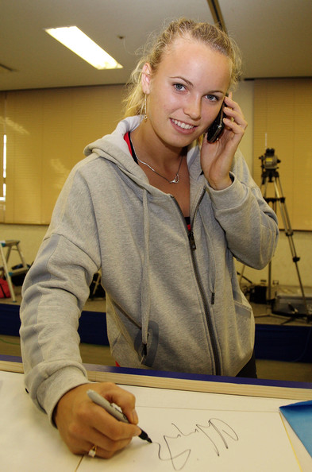
Listen and repeat
Dialogue 8: May I take a message.

A: Hello, Ultimate Computers. May I help you?
B: Yes, this is Jack Kordell from Hunter's Office Supplies. May I speak to Elaine Strong, please?
A: I'm sorry, but she's not in right now.
B: Okay, do you know when she'll be back?
A: Uh, yes, she should be here later on this afternoon maybe about 4:30. May I take a message?
B: Yes. Ms. Strong sent me a brochure detailing your newest line of laptop computers with a description of other software products, but there wasn't any information about after-sales service.
A: Oh, I'm sorry. Would you like me to fax that to you?
A: Yes, but our fax is being repaired at the moment, and it won't be working until around 2:30. Hum . . . could you try sending that information around 3:30? That's should give me time to look over the material before I call Ms. Strong, say, around 5:00.
A: Sure. Could I have your name, telephone number, and fax number, please?
B: Jack Kordell and the phone number is 560-1287. And the fax number is 560-1288.
A: Okay. Jack Kordell. Is your name spelled C-o-r-d-e-l?
B: No. It's Kordell with a "K" and two "l's." K-o-r-d-e-l-l."
A: All right, Mr. Kordell. And your phone number is 560-1287, and the fax number is 560-1288. Is that correct?
B: Yes it is.
A: All right. I'll be sure to send you the fax this afternoon.
B: Okay, bye

Exercises : Telephone calls.

Instruction
- There are 10 questions in this paper. Task includes 4-option multiple choice.
- Answer all questions.
- Mark your answer on the separate answer sheet.
- Time 10 minutes.
- Each question in this paper carries one mark.
Choose the best option to complete each dialogue about ordering the meals.
Mark the correct letter [A,B,C,D] on your answer sheet.
------------------------------------------------------------------------------------------------------------------
Gloria : Hello ………1……………..
Woman : One moment , please. I think she’s in the garden ………2……..
Gloria : Gloria thank you.
Malee : Hi Gloria.
Gloria : Oh hi Malee……………3………….
Malee : Fine. How about you?
Gloria : OK. Thanks Malee. ………4……….. on Saturday morning?
Malee : Yes , why?
Gloria : My parents are arriving from the states and I’m meeting them. …5…..
I’d like you to be there to meet them too because you’re my best friend in
Thailand.
Malee : ………6……. I’m really looking forward to seeing them.
Gloria : Let’s meet at your house. Then we’ll take a bus to Suvarnabhumi Ariport. The
plane’s due in at 11 a.m.
Malee : Wait a minute . …………7…….. in my brother’s car? I’ll ask him. I’m sure he
won’t mind.
Gloria : Oh no ………8…………
Malee : Don’t worry. He’ll be happy to do it. We want to show your parents. ……9…...
Hloria : Great! ………10……… Are you sure?
Malee : Of course , We’ll see you at ten on Saturday. Bye.
Gloria : Bye and thanks again.


1. a. I want to speak to Malee.
b. Where’s Malee.
c. May I speak to Malee?
d. Get me Malee.
----------------------------------------------------------------------------------------------------

2. a. Who are you , please?
b. What’s your name?
c. Who’s calling please?
d. Whose name is it , please?
------------------------------------------------------------------------------------------------------

3. a. How do you do?
b. What’s happening?
c. What about you?
d. How’s everything?

-------------------------------------------------------------------------------------------------------
4. a. are you free.
b. what are you doing.
c. do you go out.
d. will you go.
----------------------------------------------------------------------------------------------------------

5. a. I wonder if we will meet at the airport.
b. I want to know if you can meet at the airport.
c. Do you like coming with me to the airport?
d. Can you come to the airport with me?
----------------------------------------------------------------------------------------------------------


6. a. I like to.
b. I do it.
c. I enjoy that.
d. I’d love to

----------------------------------------------------------------------------------------------------------
7. a. Are we going?
b. Why don’t we go?
c. Do you like to go?
d. Why don’t you like going?

---------------------------------------------------------------------------------------------------------
8. a. don’t bother him
b. don’t give him trouble.
c. it’s no bother to him
d. that’s the trouble with him.
----------------------------------------------------------------------------------------------------------

9. a. my brother car.
b. some Thai hospitality
c. the Bangkok traffic
d. our modern airport.

----------------------------------------------------------------------------------------------------------
10. a. That’s rather nice if you
b. It’s my satisfaction
c. That’s really kind of you.
d. It’s my pleasure
-----------------------------------------------------------------------------------------------------------



บรรณานุกรม

Long M.N. and Richards F.C. Breakthrought. Singapere : Prppan Printing , 1977.
Telephone. [ออนไลน์]. เข้าถึงได้จาก : http://www.bbc.com/learningrnglish
(วันที่ค้นข้อมูล : 4 มีนาคม 2552)
Talking on the Phone. [ออนไลน์]. เข้าถึงได้จาก : http://www.eslfast.com/robot/ topics/
employment/employment08.htm. (วันที่ค้นข้อมูล : 2 มีนาคม 2552)
The Park Tavern. เข้าถึงได้จาก : http://www.deerparktsvern.com (วันที่ค้นข้อมูล : 28 เมษายน
2552)
Tomalin Barry. Follow me. กรุงเทพฯ : สงวนกิจ , ม.ป.ป.
You practiced ‘On the phone’ on 19/07/09. เข้าถึงได้จาก : http://www.oup.com/elt/headway
(วันที่ค้นข้อมูล : 7 มีนาคม 2552)

