วงจรปรีไมค์
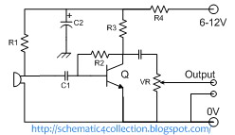

Parts List :
Parts | Description
R1 | 10 KΩ
R2 | 220 KΩ
R3 | 5,6 KΩ or 5K6
R4 | 560 Ω
VR | 10 KΩ
C1 | 100 nF Polyester Capacitor
C2 | 47 µF 16V Electrolytic Capacitor
C3 | 4,7 µF 16V Electrolytic Capacitor
Q | C828 NPN Transistor

